Programming worksheet
Task 1: Exam grades
Write a program that asks the user to enter a mark in the range 0 to 100 and outputs the corresponding exam grade, as in the following table:
Mark | < 40 | 40–49 | 50–59 | 60–69 | 70–79 | 80–100
Grade | U | E | D | C | B | A

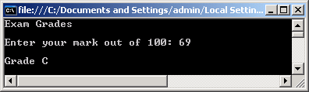
Task 2: Discounts
An electronics company gives its customers the following discounts:
Order value | < £1000 | < £2500 | < £5000 | < £10,000 | £10,000 or more
Discount | 0 | 5% | 10% | 15% | 20%

Write a program to calculate and display the discounted price for orders, as in the following console session:
